**Brooklyn torah gazette**

**For parshas Va’era 5782**

Volume 6, Issue 15 (Whole Number 270) 28 Teves 5782/ January 1, 2021

**Printed L’illuy nishmas Nechama bas R’ Noach, a”h**

For a free subscription, please forward your request to [***keren18@juno.com***](mailto:keren18@juno.com)

**Rabbi Berel Wein**

**On Parshas Vaeira**

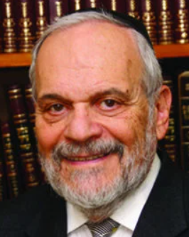

Many of the Torah commentaries point out that unlike our forefathers, Moshe, in this week's opening verses to the Parsha, did not accept that G-d's promises of redemption for the Jewish people had not yet been fulfilled. In G-d's response to this, we sense a veiled criticism of our great teacher and leader Moshe.

Heaven responded to Moshe by saying that he enjoyed a higher and different relationship to the Revelation from G-d than those original founders of the Jewish people. Because of this state of elevated Revelation, Moshe's complaint was unnecessary. Moshe should have realized that Heaven has its own timetable, and that its promises will always be fulfilled, but not necessarily according to the time schedule established by human beings.

It is difficult to understand the attitude in Moshe's statement to Heaven that it had not yet freed the Jewish people from Egyptian bondage. Moshe certainly realized through his powers of Revelation that he had experienced, and through the commitments made to him and to the Jewish people about redemption, that Heaven was aware of the promises, and that there was no need to be prompted by Moshe to fulfill its commitments.

However, Moshe, like all leaders, was subject to public pressure, complaints and hostility directed towards him by the Jewish taskmasters after the decree of the Pharaoh to withhold straw from them, while demanding the same number of bricks to be produced. These complaints by the people were deeply disturbing to Moshe. He deflects the criticism directed towards him and, instead, holds Heaven accountable for the situation.

Moshe, himself, has no doubt as to the eventual outcome and the inevitable redemption of Israel from Egyptian bondage. Unlike Abraham, Isaac, and Jacob though, he was subject to popular opinion in the mood of the Jewish people, whom he had to convince that redemption would in fact take place.

According to the Midrash, many, if not most, of the Jewish people in Egypt did not believe Moshe’s promises that they would soon be delivered from Egyptian slavery. Even after the series of plagues and punishments visited upon the Egyptians, most of the Jews still did not believe in their coming redemption. In contending with this psychological and emotional state of mind by a large part of the Jewish people, Moshe necessarily turns the Heaven for help. He has no doubt that the redemption from Egyptian slavery will shortly take place. However, he must bring the masses of Israel along with him in this belief and faith.

Because of his great modesty and humility, Moshe does not rely upon his own powers of persuasion to accomplish this task, and he turns to Heaven in an almost provocative fashion. He implores G-d to hasten the process of the delivery of the Jewish people from Egyptian bondage. His courageous words to Heaven, which seem like a complaint, are, indeed, but an expression of the greatness of his character and the forcefulness of Moshe's leadership.

*Reprinted from this week’s website of rabbiwein.com*

# Rav Avigdor Miller on

# Happiness with No Children



**QUESTION:** **How can someone who is constantly sad because they have no children, be thankful to Hashem?**

**ANSWER:** And the answer is, the Chovos Halevovos says that if you are one of the privileged ones who has no children, you should thank Hashem always. You should be grateful that He absolved you from the obligation of children.  
 Now pay attention.

What do you we need children for? Are we little girls that we need baby dolls? Something to play with? It’s irrational. And it’s selfish. That’s what children are for?

**Children are a Responsibility from Hashem**

Children are given to us by Hashem as a responsibility. However, it’s our job not to dodge it. Certainly, you have to marry young and have as many as you can because that’s Hakodosh Boruch Hu’s command. פרו ורבו! You must do that.

And as they come and the obligations are raining down upon you, you’re going crazy from even one child; so go crazy from ten. It’s the same thing. It’s a big mistake; women think if they don’t have more, they won’t go crazy. I’ve seen woman who claim they are crazy from one baby. So, you might as well go crazy over a lot.

But suppose Hakodosh Boruch Hu didn’t give; so it’s silly for a person to waste his life in sadness. On the contrary, breathe a sigh of relief, like the Chovos Halevovos says, and be grateful; now you can go ahead and do the great things in life.

How many women have time to read a Kuzari or to read the Chovos Halevovos – in translation you can read it too. A woman can become great now that she has no children. She’s not of that bent of mind? She can become great in gemilus chassodim. There are careers in helping other people; a lot of things to do that mothers of families cannot do.

Now, mothers of families תבוא עליהם ברכה – blessed should they be with all their chores; certainly Hakodosh Boruch Hu will reward them. But the Chovos Halevovos says that you should thank Hashem when you have no children because He has exonerated you from those obligations and now you can do a lot of things that people with children cannot do. And don’t waste your life mourning because that shows that you don’t understand the purpose of life.

**The Purpose of Life is to Serve Hakodesh Boruch Hu**

The purpose of life is to serve Hakodosh Boruch Hu. How do you serve Him? In whatever manner He requires of you. So, if he deposits children on your doorstep, so that’s what’s required of you. And if He doesn’t, so He requires other things. And there’s so many requirements in life that there’s never any spare time. Never do you have any leisure times to take off from avodas Hashem.

And so people should always be busy in serving Hashem in one way or the other. To utilize life for its purpose; whether it’s by raising children or by raising somebody else’s children or by raising money for people to have children or by raising your mind to heights of avodas Hashem by creating a mind filled with all the attitudes and ideals of the Torah.

*Reprinted from the December 20, 2021 email of Toras Avigdor (Tape 457)*

*\*\*\*\*\*\*\*\*\*\*\*\*\*\*\*\*\*\*\*\*\*\*\*\*\*\*\*\*\*\*\*\*\*\*\*\*\*\*\*\*\*\*\*\*\*\*\*\*\*\*\*\*\*\*\*\*\*\*\*\*\*\*\*\*\*\**

*Aharon threw his staff in front of Pharoah and his servants, and it became a snake* (Exod. 7:10)

Pharoah claimed that the Jews had sinned and therefore didn't deserve to be taken out of Egypt. Moshe and Aharon responded that a person's environment plays a very important role in his development. Even a holy staff can turn to a vicious snake in the company of Pharoah.

On the other hand, a "snake" in the company of Moshe and Aharon can transform itself into a holy staff.

*(HaRav Meir Shapiro M'Lublin)*

*Reprinted from Reprinted from the 5757/1997 Va’eira edition of L’Chaim Weekly, Adapted from Vedibarta Bam by Rabbi Moshe Bogomilsky*

**The Obligation to See G-dliness**

**Despite the Overwhelming**

**Darkness of Our Exile**

**From the Talks of the Lubavitcher Rebbe**

**Rabbi Menachem Mendel Schneerson, Zt”l**

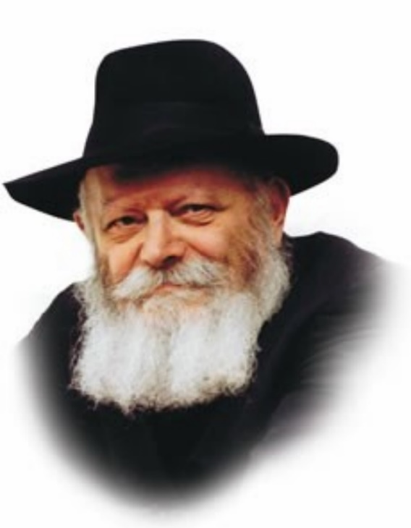

This week's Torah portion, Va'eira is very long in comparison to other Torah portions. It has numerous verses, yet they all share a common theme for the simple reason that they belong to the same Torah portion. This is expressed in the name of the portion itself (literally, "And I appeared"), which comes from the Hebrew word meaning sight. What does this teach us? That a Jew must serve G-d in a manner of "seeing."

The body and soul and antithetical; they are darkness and light. The body is darkness, yet the soul illuminates it with the light of Torah and mitzvot. And just as the physical body "darkens" the spiritual soul, so, too, does the phenomenon of exile obscure the light.

In truth, the darkness of exile is so intense that it prompted Moshe to challenge G-d. "Why have You done evil to this people?" Moshe asked. Why must the Jewish people suffer so?

In exile the Jew is anguished and tormented. His absorption in his suffering is liable to deplete his strength and crush his spirit, preventing him from serving G-d in the proper manner.

G-d's answer to this question was "Va'eira." A Jew must actually see G-d. It's not enough to know that G-d exists and to believe that He oversees the affairs of the world. A Jew must have such a strong awareness of G-d's presence that it is as if he can actually see Him.

When a person sees something, he is sure that it exists. If he hears something, he may later come to think that he has heard incorrectly. Seeing, however, is different. Once a person has seen something he can never be persuaded to change his mind. With the very first glance he absorbs the entire entity. He notes all its details and gets the full picture.

A Jew should always perceive G-d in a manner of "Va'eira." He must see the G-dliness that exists in the world, despite the concealment of the exile. This is the only way of serving G-d which ensures that the exile will not sap his strength.

Everything that is written in the Torah contains a lesson for us to apply in our daily lives. Just as Moshe challenged G-d by saying, "Why have You done evil to this people," so, too, must we never accept our state of exile or become acclimated to it.

Yes, a Jew can certainly learn Torah and perform mitzvot in exile, but we must never come to terms with our present situation or concede that it continue. Like Moshe, we must cry out to G-d from the depths of our heart, "Why have You done evil to this people? The time for our Redemption has arrived!" At the same time we must continue our Divine service with full faith and confidence, "seeing" the G-dliness that exists all around us.

*Reprinted from Reprinted from the 5757/1996 Va’eira edition of L’Chaim Weekly, adapted from Likutei Sichot, volume 2*

*\*\*\*\*\*\*\*\*\*\*\*\*\*\*\*\*\*\*\*\*\*\*\*\*\*\*\*\*\*\*\*\*\*\*\*\*\*\*\*\*\*\*\*\*\*\*\*\*\*\*\*\*\*\*\*\*\*\*\*\*\*\*\*\*\*\**

*The magicians said to Pharoah, "This is the finger of G-d."* (Exod. 8:15)

Only after the plague of lice did the magicians say that the plagues were indeed "the finger of G-d." The first two plagues, blood and frogs, originated from the water. The magicians then told Pharoah that G-d's power is limited only to the water. G-d responded with a plague of lice, extremely minute creatures that come from the earth. Upon seeing this, the magicians were forced to concede that G-d is indeed Omnipotent. *(Shaar Bat Rabim)*

*Reprinted from Reprinted from the 5757/1997 Va’eira edition of L’Chaim Weekly, Adapted from Vedibarta Bam by Rabbi Moshe Bogomilsky.*

# Shtadlanim:

**Harold M. Jacobs**

**By Dr. Rafael Medoff**

**[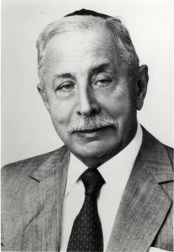](https://jewishaction.com/content/uploads/2021/11/Jacobs1.jpg)**

**Harold M. JacobsCourtesy of Yeshiva University Archives**

In an era when most American Orthodox leaders were accustomed to focusing their attention within the Orthodox community, Harold M. Jacobs (1912-1995) was one of the pioneers of a new model of leadership, demonstrating that it was possible in post-World War II America to proudly maintain a traditional religious lifestyle while actively representing Jewish interests at the highest levels of the secular world.

The son of an immigrant peddler, Jacobs grew up in Williamsburg and was educated at Torah Vodaath high school and St. John’s College, eventually completing a master’s degree in economics at Columbia University.

He exhibited a prescient business sense, founding a company to manufacture airplane parts just before World War II created an enormous demand for them, and then manufacturing wooden kitchen cabinets just as the postwar surge of suburban home construction caused a vast expansion of that market.

**Leader of a Number of**

**Orthodox Institutions**

Jacobs’ business success and subsequent prominence in the Jewish community paved the way for his leadership of a number of Orthodox institutions.

In the 1950s, he served on the boards of several major yeshivas and was president of Young Israel of Eastern Parkway and the Crown Heights Yeshiva.

The Jewish Press reported that Jacobs was “active in every major and minor Jewish organization in Brooklyn.” Friends nicknamed him “the mayor of Crown Heights.”

Jacobs’ first foray into the realm of shtadlanut was the battle against New York State’s “blue laws,” which endangered the livelihoods of Orthodox Jewish merchants by forcing them to close on Sunday.

As chairman of the Joint Committee for a Fair Sabbath Law, Jacobs led delegations of Jewish leaders to Albany to lobby legislators, mobilized Christian allies and utilized his contacts in the Brooklyn branch of the Democratic Party in a years-long campaign that resulted in the elimination of the law.

**Harold Jacobs, and other young activists in the emerging class of postwar American Orthodox leaders, forged new paths of influence both in the Jewish community and beyond.**

**A Time of Growing Tension**

**Between Jews and African Americans**

Warming to the role of Jewish spokesman to the wider world, Jacobs chaired the Brooklyn Jewish Community Council in the late 1960s and early 1970s, a time of growing tension between Jews and African Americans in New York City.

He spoke out against the anti-Semitism that erupted during the Oceanhill-Brownsville teachers strike, and headed a committee of Brooklyn Jewish leaders seeking to persuade Mayor John Lindsay to reinstate the teachers.

As president of the OU from 1972 to 1978, Jacobs oversaw a major expansion of NCSY’s outreach work, the opening of the OU Israel Center (now the Seymour J. Abrams Orthodox Union Jerusalem World Center) and the Zula Center (now known as Pearl & Harold Jacobs Zula Outreach Center) and an OU program to help Jewish residents relocate from deteriorating inner city neighborhoods. He also brokered a compromise to diffuse controversy within the OU over participation in the Synagogue Council of America.

[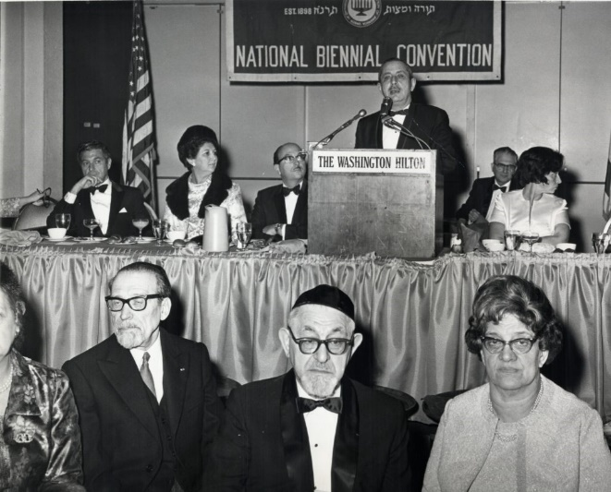](https://jewishaction.com/content/uploads/2021/11/Jacobs2-scaled.jpg)

**Harold Jacobs speaking at the 1968 OU National Biennial Convention. Courtesy of Yeshiva University Archives**

During his term as leader of the OU and later as president of the National Council of Young Israel, Jacobs cultivated relations with local and national political leaders in order to advocate for Jewish concerns. He was particularly active in opposing US pressure on Israel, lobbying against

arms sales to belligerent Arab regimes, and combating the influence of anti-Israel elements within the Democratic Party.

At the same time, Jacobs played an increasingly active role in civic affairs, rising to the chairmanship of New York City’s Board of Higher Education in 1976. Jacobs steered the city’s educational system through crises over college admission policies, tuition disputes and campus anti-Semitism.

Harold Jacobs represented a new type of Orthodox shtadlan. The pre-World War II generation of Orthodox leaders, having arrived in the United States relatively recently and still learning America’s ways, had only a limited impact on public policy issues.

Jacobs and other young activists in the emerging class of postwar American Orthodox leaders, however, forged new paths of influence both in the Jewish community and beyond.

Dr. Rafael Medoff is the author of more than twenty books about Jewish history, including Building Orthodox Judaism in America: The Life and Legacy of Harold M. Jacobs (2015).

Reprinted from the Winter 2021 issue of the Orthodox Union’s Jewish Action magazine.

**Thoughts for Our Parsha**

*Moshe spoke this to the children of Israel; but they did not listen to Moshe because of anguish of spirit and cruel bondage* (Exod. 6:9)

Moshe brought good tidings to the Jews, but they didn't heed his words. Originally, G-d told Avraham that the Jews would be enslaved for 400 years, but Moshe appeared to them with the good news after only 210 years. G-d chose to take them out of Egypt earlier for two reasons.

First, the Jews had declined spiritually to the point that they were in danger of assimilation. Second, the Egyptians exploited them so harshly that it was as if they had worked for 400 years. The Jews knew that they were supposed to be enslaved for 400 years, so when Moshe told them of their imminent liberation after 210 years, they didn't believe his explanation that it was due to "anguish of spirit" -- spiritual decline, and "cruel bondage" -- excessive labor. *(Pardes Yosef)*

*Reprinted from Reprinted from the 5757/1997 Va’eira edition of L’Chaim Weekly, Adapted from Vedibarta Bam by Rabbi Moshe Bogomilsky.*

**A Jewish Couple Saved a Church. Their Generosity Ended Up Saving Jewish Lives**

**By Menucha Chana Levin**

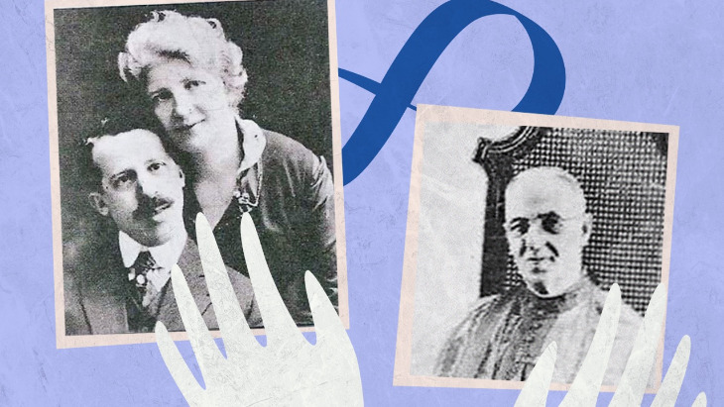

*Solomon and Esther Ueberall raised the funds needed to keep a New York church open. Decades later during the Holocaust, their generosity was repaid in a remarkable manner.*

Solomon and Esther Ueberall, a newly married Jewish couple, owned a small notions store on Myrtle Avenue in Brooklyn in 1913. Both were immigrants, he from Austria, she from Russia, whose families came to America seeking sanctuary from religious persecution.

One day Father George Caruana, the young priest of the local Italian Church of St. Lucy, walked into the store to buy a pair of shoelaces.

“What’s the matter? Why do you look so sad?” Solomon asked him.

The priest explained to Solomon that the mortgage on his store-front church was due soon but he was unable to raise the additional $500 needed to pay it off. He had gone door to door asking the parishioners to donate as much as they could but it still wasn’t enough to cover the considerable payment due ($500 was worth $14,000 in today’s currency).

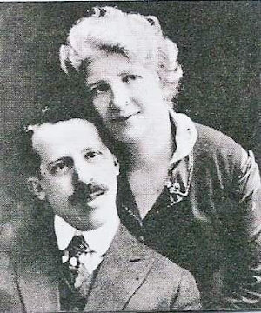

***Solomon and Esther Ueberall***

Father George felt it was likely they would lose their church. Saddened by the prospects of no place for Sunday worship, he decided to go for a walk and pray for guidance when he noticed Solomon’s store.

Listening intently, Solomon was touched by the priest’s words about these poor immigrants about to lose their place of worship due to lack of funds. As Father Caruana turned to leave the store with his shoelaces, Solomon called out and reassured him, “Don’t worry, I’ll get the money for you.”

The incredulous priest just waved and walked on. Solomon’s wife Esther was even more skeptical, unable to believe what she had heard.

**They didn’t even have five dollars. Where were they going to get $500, worth $14,000 at the time?**

“Solomon, you know we don’t even have five dollars, where are we going to get $500?” she asked.

“You know those beautiful wedding gifts we received? Well, we don’t need them right now,” Solomon explained. “I can take them to the pawn shop and lend the money to the church. When they pay us back, we can retrieve our gifts, but in the meantime the people can worship in their church.”

With Esther’s agreement, Solomon took all their wedding gifts to the local pawn dealer, but he was only able to receive a total of $250 for everything. Solomon was determined to keep his promise.

He told Esther he would borrow the rest of the money from members of his large extended family, his uncles, brothers-in-law and cousins. Some were sympathetic to the cause, while others were reluctant. Finally, in bits and pieces, he managed to obtain the full $500 necessary to pay off the church’s mortgage.

As promised, Father Caruana and successive pastors were at the Ueberall’s store every Monday morning with a portion of the Sunday collections until the debt to Solomon was fully paid off.

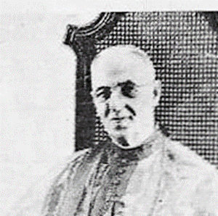

***Father George Caruana***

In 1914 the new church building was substantially completed. When Father Caruana was transferred to a church in Queens to become its pastor, he and Solomon said goodbye to each other. They lost contact as the congregation grew larger and the Ueberall notions store expanded to become the Ueberall Department Store. After Solomon died in 1920 of a heart attack Esther continued to operate the department store with the help of her family.

**Pleas for Help**

Years later, as Hitler’s army was expanding into other European countries, Esther began receiving letters from Solomon’s relatives and friends in Austria. They were pleading for assistance to seek admission to America to avoid the Nazi concentration camps. Esther worked tirelessly to obtain visas for many of them but the letters continued to arrive as the immigration quotas were filled. The letters were so heart-rending, Esther was highly distressed and would not give up. Just as her husband had persisted to collect the money for the church, she struggled to save the lives of his family members.

**As Hitler’s army expanded into other European countries, Esther began receiving letters from Solomon’s relatives and friends in Austria pleading for help.**

As a last resort she traveled to Washington D.C., where she visited with personnel from various organizations and federal offices including immigration officials from the State Department. No one had any solutions.

Reaching the point of despair, a young man from the Labor Department told her that European refugees could still find sanctuary in Cuba if a prominent individual there would vouch for them and assure the Cuban government that they would not become a burden of the state.

At first Esther felt encouraged by this information, viewing it as a glimmer of hope. But on her way home to Brooklyn, her hopes crashed when she realized she knew nobody in Cuba. Then it occurred to her that Cuba was a Catholic country. She went straight to the Church of St. Lucy where she met the current pastor, Father Anthony De Liberty. She told him that she desperately needed his help. He gave her a letter of introduction and cabled the papal nuncio in Cuba, informing him of the situation and that Esther would be arriving in Cuba shortly.

**The Priest in Havana**

With many lives were at stake, Esther wasted no time and flew to Havana two days later. As she walked off the plane a young boy presented her with a bouquet of roses. Puzzled, she looked up and saw a slender, red-robed, priestly figure standing there smiling at her. Extending his arms outward, he asked, “Esther Ueberall, don’t you remember me?”

Staring at him in disbelief, she whispered, “Father Caruana…” and burst out crying.

He explained that he was now an archbishop and the papal nuncio to Cuba, and fully aware of the purpose of her visit as described by Father De Liberty’s cable which he received. He promised Esther that he would do everything in his power to assist her in this urgent situation.

**Archbishop Caruana was able to arrange for more than two dozen of Solomon’s family members to escape Hitler and get into Cuba.**

As they were being driven back to his office, she wondered aloud, “How could this be, after all these years, we would be reunited in Cuba, and you an archbishop?”

He explained that in 1921 he was appointed bishop of San Juan, Puerto Rico and later assigned to papal diplomatic positions in Mexico and Haiti. Finally, in 1935, he was appointed apostolic nuncio to Cuba by the Vatican. This prominent position allowed him to deal directly with the Cuban government. His office became even more influential when his friend in Rome, Cardinal Pacelli, became Pope Pius XII in 1939.

Through persistent hard work, Archbishop Caruana was able to arrange for more than two dozen of Solomon’s family members to escape Hitler and get into Cuba. While awaiting visas to America, they were prohibited from working in Cuba and he provided them with housing and food including kosher meat.

**

Esther was forever grateful to the archbishop. A few years after the war ended, he became ill and was sent to a hospital in Philadelphia where Esther visited him before he passed away. The Italian immigrants in Brooklyn also remembered the generosity of their Jewish benefactors. As they completed the construction of their church, they inserted, in the center of the ceiling grates, a star of David.

Reprinted from the December 25, 2021 website of Aish.com

**Thoughts for Our Parsha**

*I will make a distinction between My people and your people* (Exod. 8:19)

Only concerning the plague of arov (wild animals) did G-d specify that there would be a distinction between the Jews and the Egyptians. This plague went against nature in that animals from different species roamed the land together. One might have concluded that since G-d removed all natural boundaries and distinctions, Jews and Egyptians would be allowed to mix. G-d insisted that even in a time when mixture and confusion are prevalent in the world, it is forbidden for Jews to assimilate. *(The Lubavitcher Rebbe)*

*Reprinted from Reprinted from the 5757/1997 Va’eira edition of L’Chaim Weekly, Adapted from Vedibarta Bam by Rabbi Moshe Bogomilsky.*